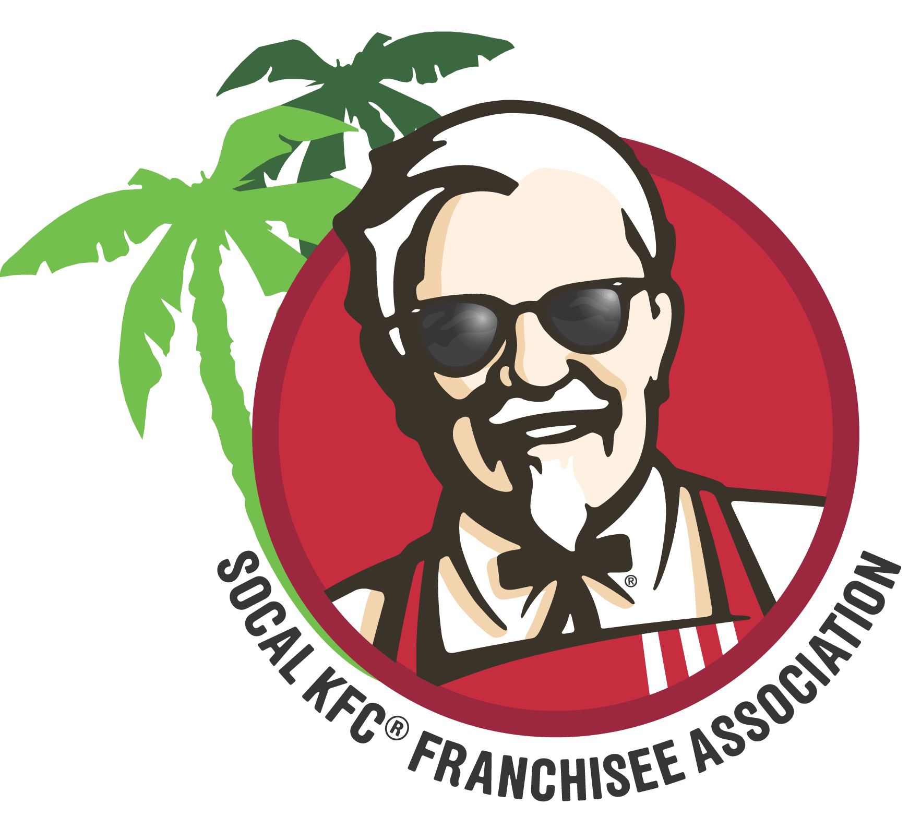2024 REGIONAL SUMMER MEETING

Monday- August 26th
8am – 12pm Pickleball
MORNING Business Partner (Vendor) Tabletop Set-up
9am Registration- Vendors and Franchisees
1pm – 3pm LUNCH/Exhibits and lunch with Vendors
3pm – 6:30pm CLOSED- Franchisee/Representative only Meeting
6:30pm - 9:30pm Dinner and Vendor Appreciation/ Franchisees and Vendors
*Dinner, bar
Tuesday- August 27th
8am – 9am BREAKFAST (continental)
8am Registration opens for managers
9am – 12:30pm Franchisee and Managers Meeting
12:30pm – 2pm LUNCH/Exhibits and lunch with Vendors
2 – 5pm Managers meeting, recognition and workshops
5pm Wrap up and meeting concludes

