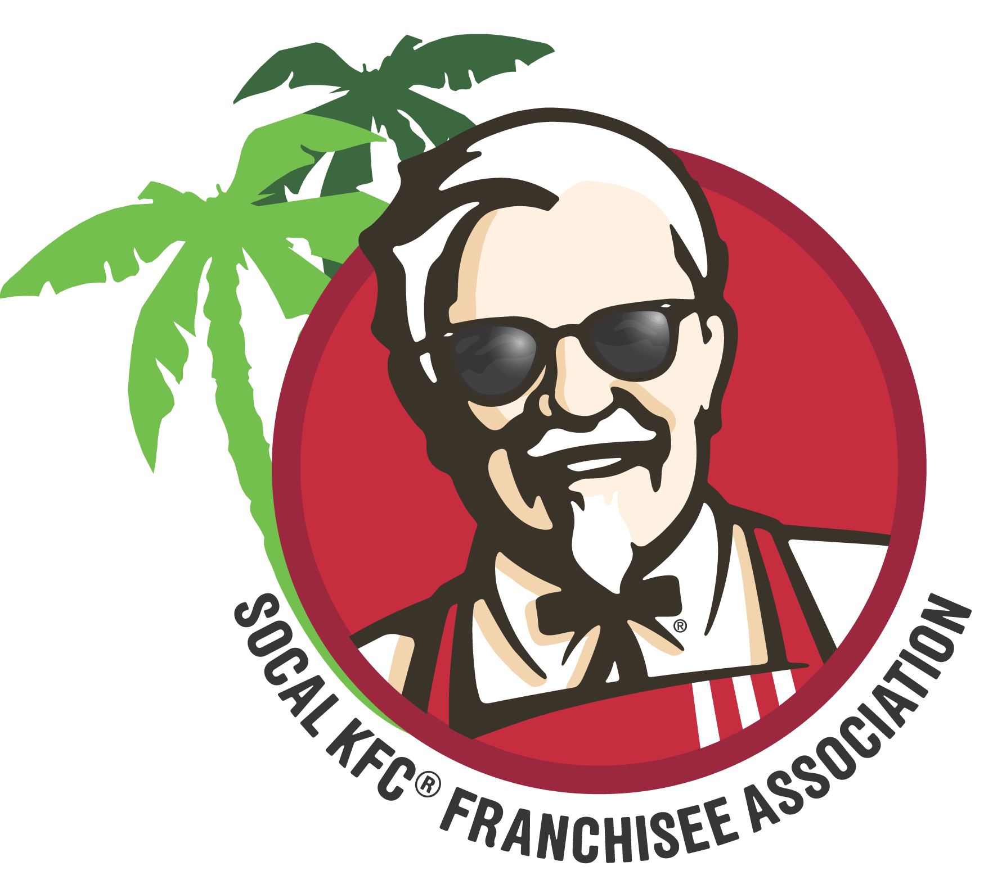
Dear Business Partners/Vendor:
The 2017 Spring Meeting is coming in May and we have an informative and educational agenda planned for our franchisees and their RGM’s. This is a great opportunity to meet them face-to-face on a personal level to promote your company’s service/products!
Tuesday – May, 16, 2017 8 AM – 5:00 PM (registration opens at 7AM)
Hilton Universal City, 555 Universal Hollywood Dr., Universal City, CA 91608
Business Partner/Vendor Exhibits & Breakfast with Franchisees 8:00AM - 9:00AM
Morning business session (Franchisees) 9:00AM - 12:15PM
Business Partner/Vendor Exhibits & Lunch with Franchisees 12:30PM - 2:00PM
Afternoon business session (Franchisees) 2:00PM – 5:00PM

.

If you need a hotel room, we have a discounted Group Rate $189+tax per room.
Call reservations at (818) 623-1434 code#SCKFC to make reservations by 4/23/17 to get discount!

Attendee’s Name ___________________________________________________________________
(Last) (First) (Middle)

2nd Attendees Name _________________________________________________________________

Company Name & Contact ____________________________________________________________

Contact Name ______________________________________________________________________

Mailing Address _____________________________________________________________________

_____________________________________________________________________
(City) (State) (Zip)

Business Phone ( )________________ Fax ( ) _________________Email______________________

􀂃 Registration Fee: $800 ($900 onsite) for 2 attendees.
Registration includes all scheduled meals for 2 people, and standard 6’ x 30” table top.
Your check should be made payable and sent to:
So Cal KFC Franchisee Association, P.O. Box 4518, Culver City, CA 90231
Please note Special needs/electrical/shipping (below):

__________________________________________________________________
(there is a nominal fee for electric and shipping)
ALL FORMS NEED TO BE IN BY: April 15, 2016 Amount
______ Business Partner Registration (2 attendees) @ $800.00 = _________
______ Additional attendees (after first 2) @ $150.00 = _________
______ Annual Membership (if not paid in Fall 2016) @ $200.00 = _________
______ Sponsorship (non-speaking)- see attached @ $750.00 = _________
TOTAL = ___________
Have questions…call our Administrative Director, DEBORAH OSSANLO, (310) 422-6464; email: ossanlokfc@aol.com or fax (310) 839-0188
Looking forward to seeing all of you!
Shahid Chaudhry, President So Cal KFC Franchisee Association

